 **SRI SAKTHI INSTITUTE OF ENGINEERING AND TECHNOLOGY**

PROJECT GUIDE   
Mr. S DHAMOTHARAN

ASSISTANT PROFESSOR

PRESENTED BY  
DINESH PON ESWARAN I (714019105007)

PRAYAN M (714019105032)  
SHRI HARSHAN (714019105042)

**PROJECT REPORT**

**RFID BASED ATTENDANCE SYSTEM**

**ABSTRACT**

The main functionality of the project is to identify the attendance of the user who needs to access it through RFID. For this purpose, the authorized person is given an RFID card. This card contains an integrated circuit that is used for storing, processing information through modulating and demodulating of the radio frequency signal that is being transmitted. Thus, the data stored in the card is referred as the identification of the attendance of the person. Once, the person places the card in front of the RFID card reader, it reads the data and verifies it with that data present in the system and if it matches then it displays a message as valid entry and allows accessing the device or else displays invalid and denies the access/attendance.

**PROPOSED SYSTEM**

* There are different technology available to store the data like adafruit, cloud computing etc…
* But here I have used an PLX DAQ software tool, which is inbuilt with an excel sheet
* So if the RC522 receives the RFID , then the data will be stored in the excel sheet of PLX DAQ tool .
* In my project there is no need of connecting internet to the system .
* This method is very useful for schools and colleges

**ALGORITHM IMPLEMENTED**

Built the code in arduino ide

Upload the code in Arduino board

First detect the output through the serial monitor

Then install the PLX DAQ software tool

Enable PLX DAQ with the Arduino

Put the RFID tag in front of the receiver RC522

The receiver data will be stored in the excel sheet

**HARDWARE & SOFTWARE**

* Arduino uno
* RC522
* RFID tags
* Bread Board and connecting wires
* PLX DAQ tool. (Parallax microcontroller data acquisition add on tool for Microsoft excel)

**OUTPUT AND RESULTS**

**HARDWARE CONNECTION**

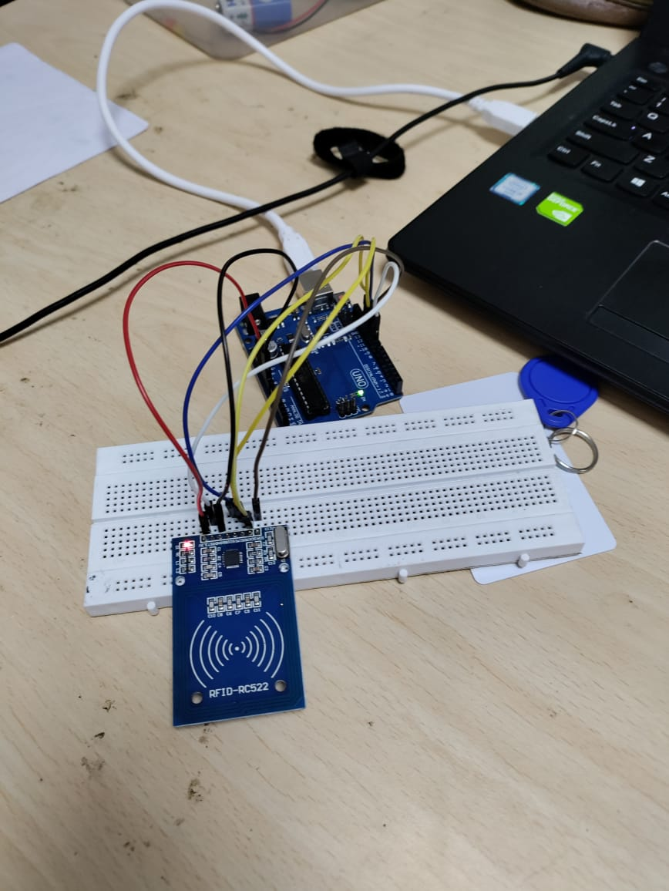

**EXCEL OUTPUT**

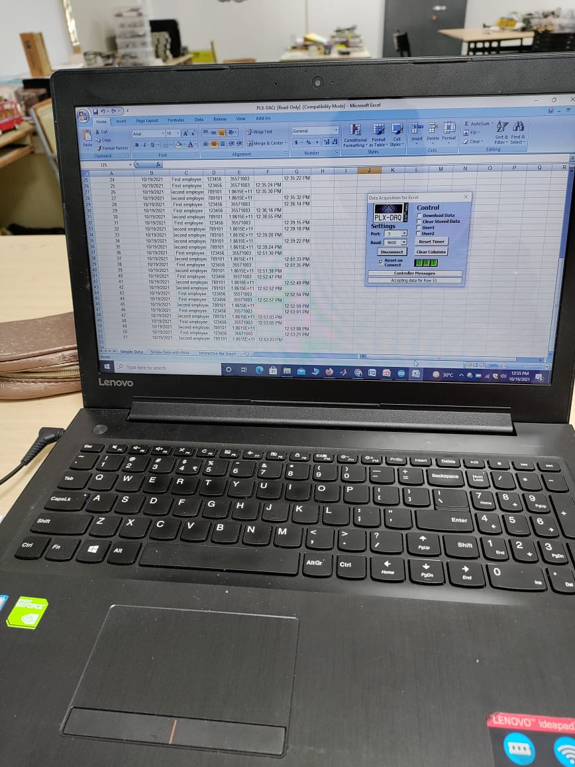

**FUTURE SCOPE**

* Range of RFID reader can be increased, so the reader can detect the tag from far distance.
* RF TRANSRECEIVER module can be used for long distance communication to transfer data.
* The transferred data can be saved and stored in computer as a database using specific software.
* Timely attendance can be monitored (i.e.time in and out) can be barcoded using RTC(real time clock) and can be stored in the database.
* This attendance system’s database can be linked with college website and can be shared and monitored by the student’s parents.
* We can send this data through internet to the user. So that user can access it remotely via internet.

**REFERENCES**

* [1] K. Domdouzis, B. Kumar, and C. Anumba, “Radio-FrequencyIdentification (RFID) applications: A brief introduction,” ScienceDirect: Adv. Eng. Informatics, vol. 21, pp. 350–355,
* [2] D. Dressen, “Considerations for RFID technology selection,”Atmel Appl. J., pp. 45–47, 2004.
* [3] A. Digital and R. Technology, “Classic RFID module products,”no.April, 2008.
* [4] D. Mane, “Importance and Analysis of RFID in AttendanceSystem,” International Journal of Emerging Science and Engineering(IJESE) no. 9, pp. 90–92, 2013.
* [5] A. Kassem, M.Hamad, Z. Chalhoub, and S. EI Dahdaah, “An RFID Attendance and Monitoring System for University Applications”, 17th IEEE International Conference on Electronics,Circuits and Systems-2010
* [6] Sumita Nainan, Romin Parekh, Tanvi Shah, “RFID TechnologyBased Attendance ManagementSystem”, IJCSI International Journalof Computer Science Issues, Vol. 10 -January 2013
* [7] T.S. Lim, S.C. Sim and M.M. Mansor, “RFID Based Attendance System”, IEEE Symposium on Industrial Electronics and Applications (ISIEA 2009), October 4-6, 2009, Kuala Lumpur, Malay-2009
* [8] H. K. Nguyen, M. T. Chew, “RFID-Based Attendance Management System”, 2nd Workshop on Recent Trends in Telecommunications Research (RTTR)-2017
* [9] Van-Dung Hoang ,Van-Dat Dang , Tien-Thanh Nguyen, Diem- Phuc Tran, “A solution based on Combination of RFID tags and facial recognition for monitoring systems”, 5th NAFOSTEDConference on Information and Computer Science (NICS) – 2018
* [10] Mahesh Sutar, Mahesh Patil, Sachin Waghmare, “Smart Attendance System Using RFID In IOT”, International Journal of Advanced Research in Computer Engineering & Technology